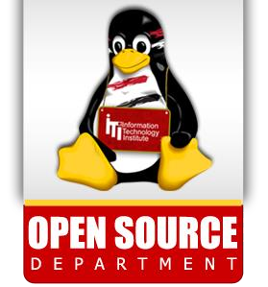

**2**

**Lab**



1. Using vi write your CV in the file mycv. Your CV should include your name, age, school, college, experience,…

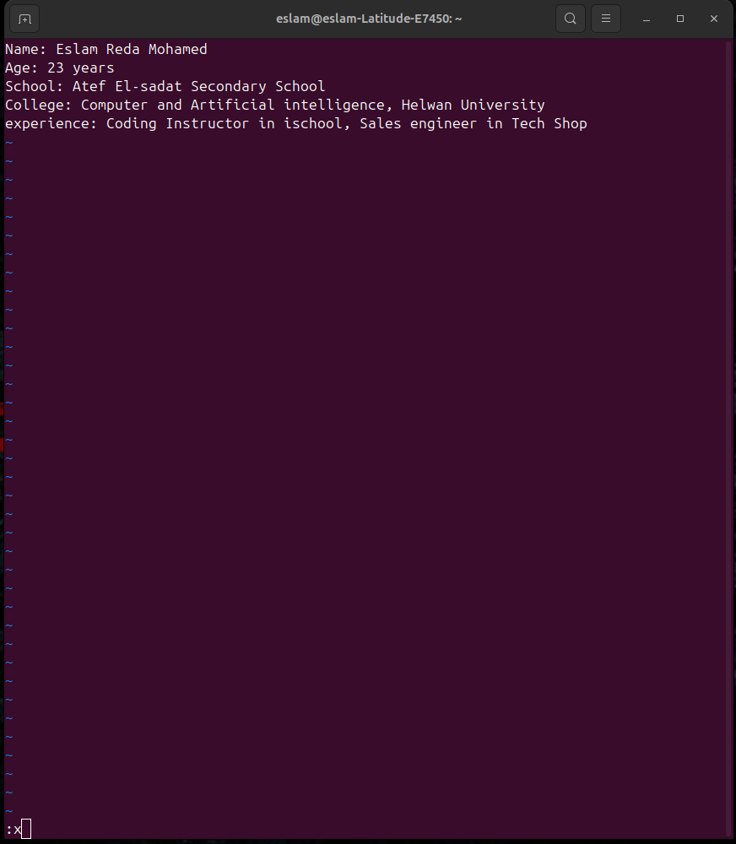

1. pen mycv file using vi command then: ( Without using arrows state how to)
2. Move the cursor down one line at time.

Press j

1. Move the cursor up one line at time.

Press k

1. Search for word age

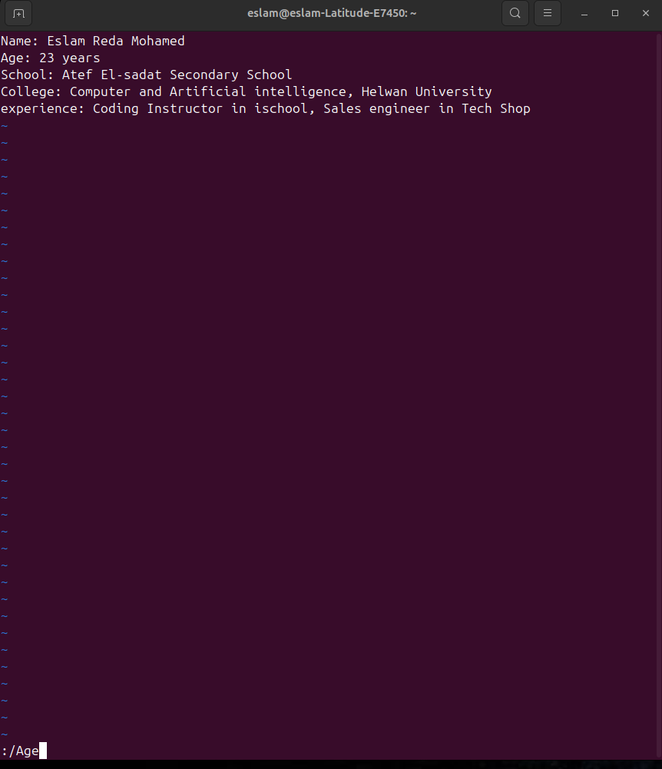

1. Step to line 5 (assuming that you are in line 1 and file is more than 5 lines).

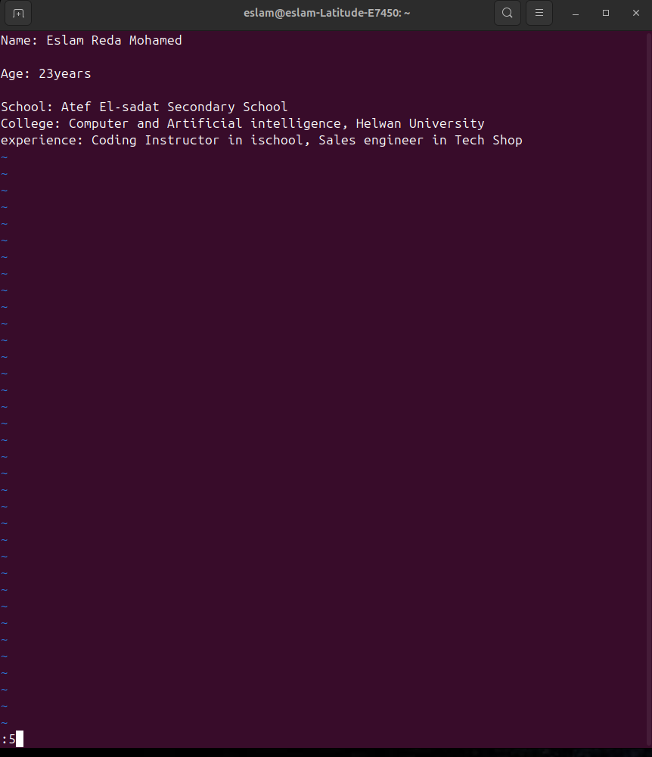

1. Delete the line you are on and line 5.

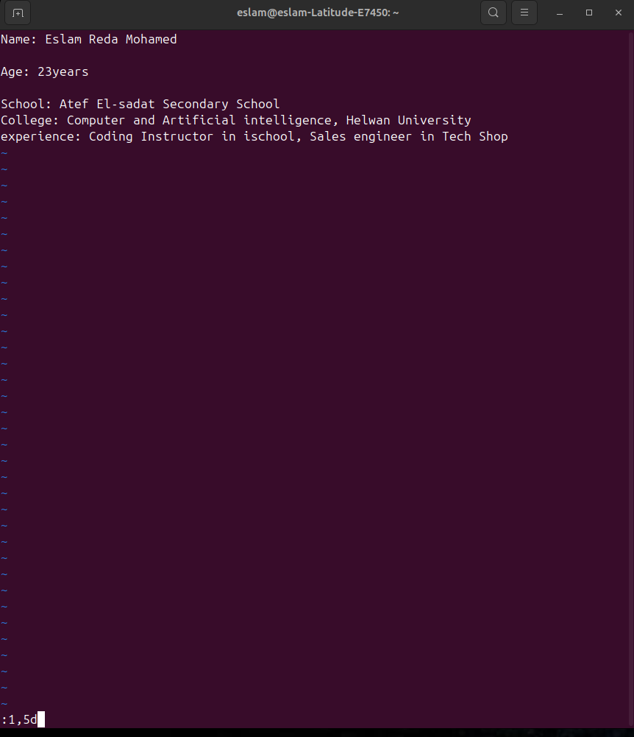

1. How to step to the end of line and change to writing mode in one-step.

Press A

1. Create a user account with the following attribute
   * username: islam
   * Fullname: Islam Askar
   * Password: islam
2. Create a user account with the following attribute
   * Username: baduser
   * Full name: Bad User
   * Password: baduser
3. Create a supplementary (Secondary) group called pgroup with group ID of 30000 12.Create a supplementary group called badgroup

12.Create a supplementary group called badgroup.

13.Add islam user to the pgroup group as a supplementary group

14.Modify the password of islam's account to password

15.Modify islam's account so the password expires after 30 days

16.Lock bad user account so he can't log in

1. Delete bad user account
2. Delete the supplementary group called badgroup.
3. Which file system has the most free disk space on your machine

20.Which top level directory n / uses the most space on your machine

21.Which top level directory in /home uses the least space on your machine.

22.Launch nautilus

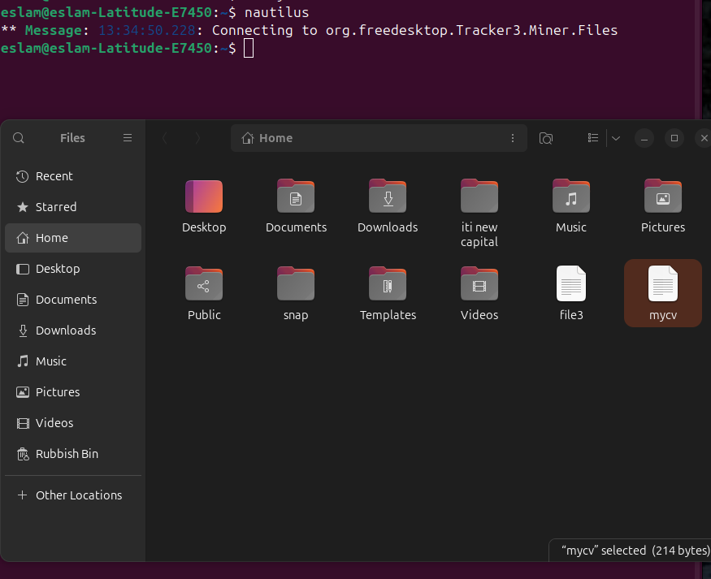

23.Create a folder called myteam

24.Change its permissions to read only for the owner







25.Log out and log in by another user



26.Try to access the folder



27.Using the command Line

1. Change the permissions of mycv file to give owner read and write permissions and for group write and execute and execute only for the others (using chmod in 2 different ways )



1. Change your default permissions to be as above.



1. What is the maximum permission a file can have, by default when it is just created? And what is that for directory.

File==>666 rw

dir==>777 rwx

1. Change your default permissions to be no permission to everyone then

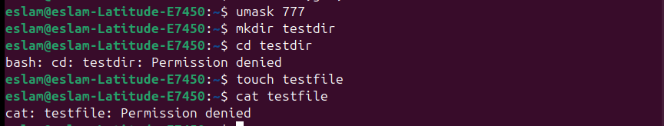

1. create a directory and a file to verify.



1. Copy a file from another user to your home directory. Note the permissions allowed to you before and after. Specify why?

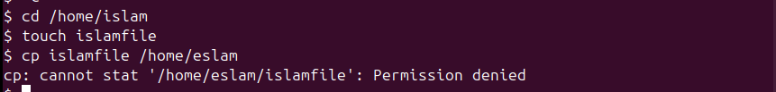

What are the minimum permission needed for :

34.Copy a directory (source and target)

source==>rx Target==>wx

35.Copy a file (source and target)

source==>r Target==>wx

36.Delete a file

wx

37.Change to a directory

w

38.List a directory content

r

39.View a file content

r

40.Modify a file content

w

1. Create a file with permission 444. Try to edit in it and to remove it? Note what happened. (notice write protection in Linux)

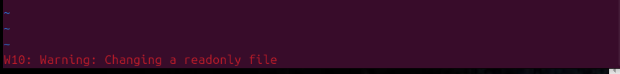

1. What is the difference between the “x” permission for a file and for a directory

dir==>You can execute the file if it is an executable. You can execute a shell script if you also have read and execute permissions.

File==>You can use the cd command to access the directory. If you also have read access, you can run the ls -l command on the directory to list contents.

1. Copy the rm program to your home directory, naming it myrm, grant set-uid permission, what happens if one of the users starts your ~username/myrm to edit one of your own files?
2. What is the difference between the set-uid and set-gid?
3. Create a directory with sticky-bit and write permissions on, grant all the users to access the directory, will any user be able to create and delete files from the directory?
4. Create a directory with set-gid permission, what do you notice when you create a new file or a directory?